DTE Energy

About company
DTE Energy (NYSE: DTE) is a Detroit-based diversified energy company involved in the development and management of energy-related businesses and services nationwide. Its operating units include an electric company serving 2.3 million customers in Southeast Michigan and a natural gas company serving 1.4 million customers in Michigan. The DTE portfolio also includes non-utility businesses focused on industrial energy services, renewable natural gas, and energy marketing and trading.
As one of Michigan's leading corporate citizens, DTE Energy is a force for growth and prosperity in the 450 Michigan communities it serves in a variety of ways, including philanthropy, volunteerism and economic progress.
DTE Energy has more than 10,000 employees in utility and non-utility subsidiaries involved in a wide range of energy-related businesses. The company's growing non-utility businesses are built around the strengths, skills and assets of DTE Energy's electric and gas utilities.
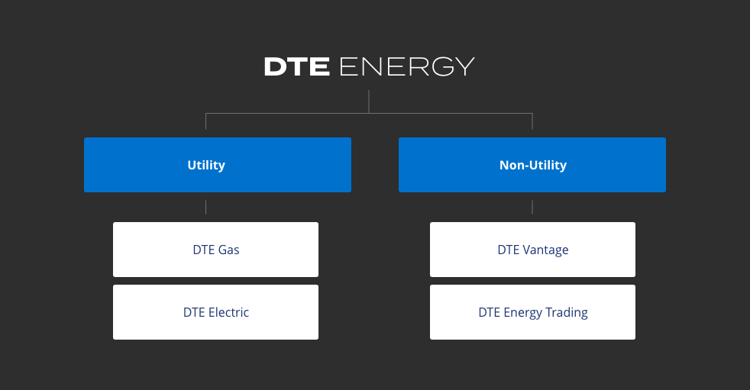

Business

Citizens Gas Fuel
Citizens is a natural gas utility company serving about 18,000 customers in and around the Adrian, Michigan area. Founded as Adrian Gas Light Company in 1856, Citizens has a history that goes back more than 160 years.
Plan Name | Monthly Cost | Coverage
HomeSmart Basic  (Plan H1 or S1) | $11.00 | The basic necessities for day-to-day living.  Coverage for a furnace and water heater.
HomeSmart Basic + Air  (Plan H4 or S4) | $14.00 | Making sure you stay cozy all year long.  Coverage for a furnace, water heater and central air conditioning unit.
HomeSmart Plus  (Plan H2 or S2) | $13.00 | Extra protection for your hardest working appliances.  Coverage for a furnace, water heater, range/oven and clothes dryer.
HomeSmart Deluxe  (Plan H3 or S3) | $16.00 | A complete package of protection!  Coverage for a furnace, water heater, range/oven, clothes dryer and a central air conditioning unit.
Plan Options & Pricing
- Coverage Additions
  - Vented Space Heaters: $3 each
  - Ductless Garage Heaters: $4 each
- Additional Appliance Coverage
  - Additional Furnace: $6 each
  - Additional Water Heater: $3 each
  - Additional Central Air: $4 each
- Senior Discount: Available—10% off total monthly cost for members aged 65+.
Cost Savings Examples
Typical out-of-pocket repair costs you might avoid:
- Furnace Control Board $500-$600
- Water Heater Control $400-$500
- Central A/C Condenser Motor $300-$400
With any HomeSmart plan, these costs are $0!

DTE Electric
DTE Electric generates, transmits and distributes electricity to 2.3 million customers in southeastern Michigan. The company uses coal, nuclear fuel, natural gas, hydroelectric pumped storage and renewable sources to generate its electrical output. Founded in 1903, DTE Electric is the largest electric utility in Michigan and one of the largest in the nation.
At 1.1 million kilowatts, the company's Fermi 2 nuclear power plant represents 30% of Michigan's total nuclear generation capacity. This single plant is capable of producing enough electricity to serve a city of about one million people. Fermi 2 has been providing reliable, cost-effective power to DTE Electric customers for more than 20 years. The plant also has been designated as one of the nation's best-performing nuclear facilities.

DTE Gas
DTE Gas is engaged in the purchase, storage, transmission, distribution and sale of natural gas to approximately 1.4 million customers in Michigan. The company owns and operates 278 storage wells representing approximately 34 percent of the underground working capacity in Michigan. There is more gas storage capacity in Michigan than in any other state. Founded in 1849, DTE Gas is one of the nation's largest natural gas utilities.

DTE Biomass Energy & DTE Power & Industrial
DTE Vantage serves the energy and decarbonization needs of industrial, commercial, agricultural, and institutional operations across North America, bringing passion and creativity to every opportunity.
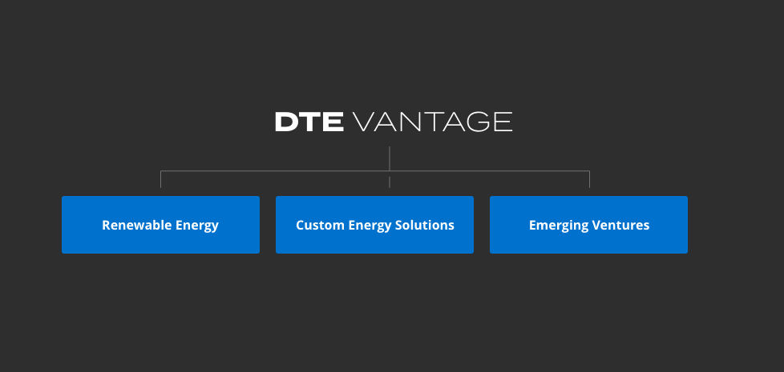

Renewable Energy
DTE Vantage Renewable Energy projects deliver enough renewable energy to its customers to power the equivalent of more than 100,000 households with cleaner, sustainable energy – a significant carbon footprint reduction.
- DAIRY TO RENEWABLE NATURAL GAS
- LANDFILL GAS TO RENEWABLE NATURAL GAS
- LANDFILL GAS TO POWER
- WASTE WOOD TO POWER

Custom Energy Solutions
Our Custom Energy Solutions team identifies and implements clean and smart innovations for energy-intensive industrial, institutional, and commercial customers. We provide energy solutions in a variety of commercial models to suit our customer’s unique needs by applying our expertise in the design, build/acquisition, ownership, and operations and maintenance of facilities.
- Data Center Energy Infrastructure
- Combined Heat and Power
- Energy Efficiency Programs
- Fuel Services
- Microgrid Solutions
- Utility Services

Emerging Ventures
We’re applying breakthrough technologies to combat climate change, the defining issue of our time. By implementing clean, smart, and safe solutions, we integrate the most promising concepts into a strategy that not only aims to meet your objectives, but also addresses the decarbonization challenges facing us all.
- OUR SHARED VISION: A NET ZERO CARBON FUTURE
  - CARBON CAPTURE AND SEQUESTRATION (CCS)
- ESTABLISHED EXPERIENCE IN NORTH AMERICA
  - Project Development and Execution
  - Site Characterization & Stakeholder Outreach
  - Regulatory & Permitting
Absorption of Long-term Site Liability
  - Operations & Maintenance
  - Monitoring, Reporting, and Verification
- FORTUNE 250 COMPANY EXPERTISE
- ENERGIZING LOCAL COMMUNITIES
History: Since its inception in the mid 1990s, DTE Vantage has created unique, sustainable solutions for our customers’ energy challenges. Building on our parent company DTE Energy’s (formerly known as Detroit Edison) 100+ years of knowledge and expertise, we began developing non-utility projects within Michigan and have expanded our reach to solve the challenges of customers across North America.
Today DTE Vantage manages and operates 60 innovative energy projects in 14 states and one Canadian province. We employ ~600 dedicated team members across our core groups: Renewable Energy, Custom Energy Solutions, and Emerging Ventures.

DEDICATION TO clean AND Smart Solutions
We combine the security and experience of an established energy leader with the entrepreneurial spirit of a start-up company, solving energy challenges facing everyone from family farms to complex operating facilities.
Our expansive portfolio of products and access to proven technologies empowers us to be a partner focused on fulfilling your environmental, social, and governance agenda. We’ll learn your business and develop a sustainable strategy that leverages the best of today’s innovations and anticipates emerging solutions.

Our Safety Commitment
Keeping our employees, customers and communities safe is the cornerstone of DTE Vantage. Building on our parent company’s 100+ year history of safely operating energy facilities, DTE Vantage maintains a culture that emphasizes the importance of reducing risk to prevent injuries. We communicate our safety commitment to ensure continuous improvement, so our host partners and local communities can be confident in our safe and reliable operations.

Supporting Local Communities
We are committed to being good corporate citizens in the many unique communities where we live and serve. Our employees volunteer with dozens of national, regional and grass-roots nonprofits, and we proudly support local businesses.
DTE’s Corporate Citizenship Report highlights the myriad of ways our values and involvement uplift our communities.

Financial Strength And Commitment
DTE Vantage is a dynamic, growth-oriented segment of DTE Energy, a Fortune 500 company with more than $12 billion in annual revenue. DTE Energy’s strong balance sheet allows DTE Vantage to invest in organizations who are committed to aggressive environmental, operating, and financial goals.
The depth and breadth of the financial support and resources uniquely positions DTE Vantage to remain a long-term partner, managing, and evolving our products and services provided as customers’ needs change.

DTE Energy Trading
DTE Energy Trading is an active physical and financial gas, power and environmental marketing company. As a subsidiary of DTE Energy—a trusted utility with $41 billion in assets and more than 170 years of energy expertise—our company has been operating since 1998.
We provide energy sourcing and management solutions for a broad range of customers such as investor-owned gas and electric utilities, municipalities, electric cooperatives, gas producers, renewable energy users and producers and independent power producers. We also manage a significant portfolio of gas transport and storage as well as power generation and transmission assets throughout the North American markets.
DTE Energy Trading has a professional, experienced staff to assist you, 24-hours a day, 7-days a week. To see how we can help you meet your energy supply and demand needs, email a DTE Energy Trading specialist today.

